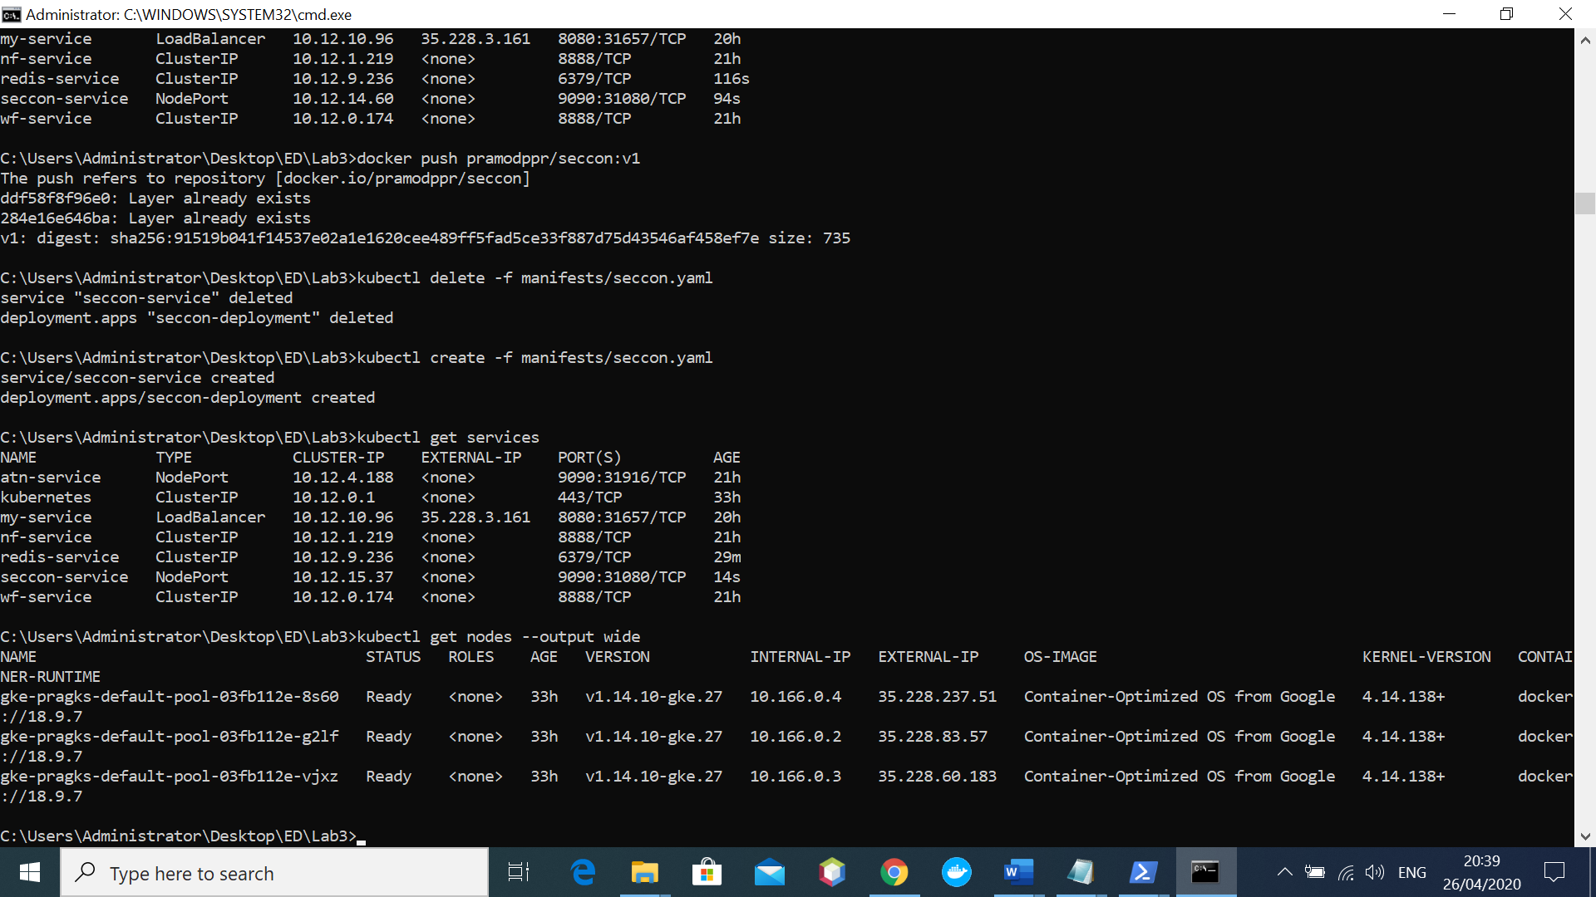
35.228.237.51: 31080/seccon
35.228.237.51:31916/allthenews/?style=plain → Workingfine
35.228.237.51:31080/ →working fine
35.228.83.57:31080/
35.228.60.183:31080/

10.12.15.37

